

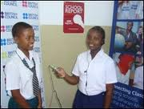
Kibogoji Experiential Learning Center brings computer access, a quality after school learning program for teenagers, early childhood literacy programs and economic opportunities to all community members in rural Tanzania.

Unlike other education programs working in Tanzanian cities, Kibogoji puts more emphasis in closing the technology and quality instruction gap between urban and rural areas in Tanzania and by so doing we hope to even the playing field.
Kibogoji Experiential Learning Center is part of the Jenga Tanzania Foundation. Jenga is a not for profit organization based in North Carolina, United States. Kibogoji aims to bridge technological and instructional quality gap between urban and rural Tanzania. Turiani is located just 55 miles from Morogoro town. Turiani is a tribal diverse low-income community of peasants and pastoralists of about 10,000+ people.
Come to Kibogoji for you and your Childs’ Educational and Technology Needs.
P.O. Box 13,
Turiani, Morogoro,
Tanzania
East Africa

What is SO special about Kibogoji?

About Kibogoji
To prepare students from an early age become competitive in the global village.
To offer quality instruction using the latest technology and research based instructional methods.

Mission


Kibogoji Experiential Learning, Inc.
Telephone +255768627780
E mail: skfundi@hotmail.com
www.webaddress.com
Education and Library:

Kibogoji Experiential Learning Center operate an after-school program called Vijana Poa. Under this project we have a one and half roomed house equipped with computers and various types of books. Vijana Poa offers an after school library run by a certified teacher.

In the future we hope to also offer field trips, virtual labs, physical activities, and computer-based academic tutoring to children age ten through nineteen Classes will be run in partnership with the surrounding primary, secondary schools, and teacher training college.

In addition, Kibogoji offer an early childhood literacy program to help our pre-k student master reading, writing, and numeracy at an early age.
“A mind is a terrible thing to waste,” by Malcolm X.

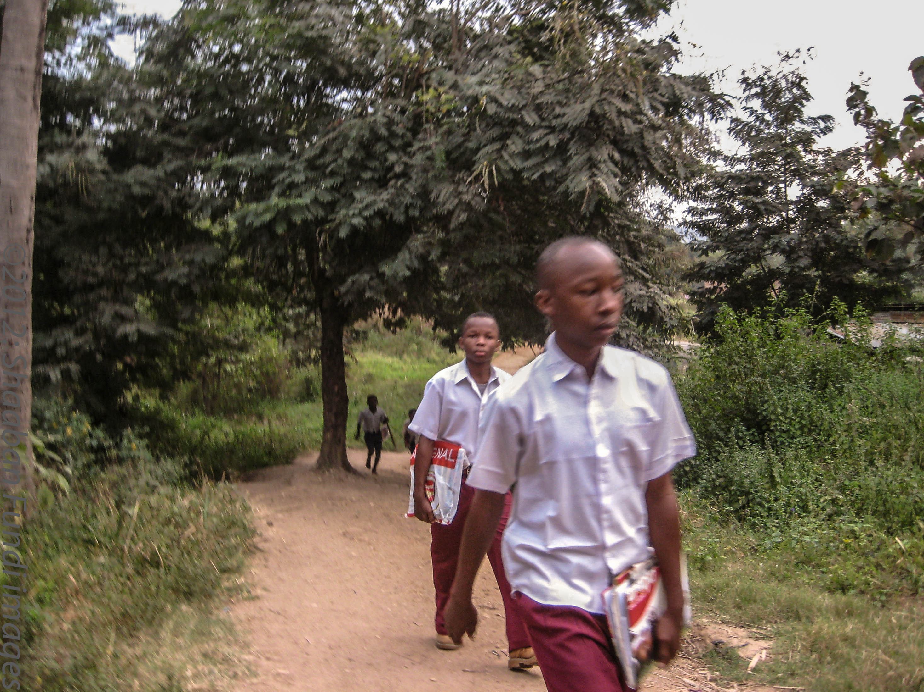

:EADLINE
Access to information:

To ensure that everyone in our community has access to daily newspapers, resource books and Internet and computer-related technologies, we operate a computer/library drop-in center.

The drop-in center operates seven days a week for 70 hours. It is equipped with a small library stocked with resource books, daily newspapers and internet.

Training the locals to use the Internet for their work and also to access government and non government sponsored programs on agriculture, jobs and health care.
Teachers Program:

Kibogoji Experiential Learning Center plans to operate a professional development program for teachers. In cooperation with the Teacher’s College in our community we hope to bring in teachers to the center to learn how to deliver engaging lessons to students using hands-on activities and project based learning strategies. This will be a Summer Program aimed at helping teacher to be familiar with 21st century best teaching practices.

Services we offer:
Collaborate with us or donate

