

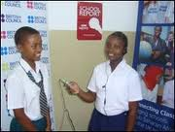
Kibogoji Experiential Learning Center, Inc. brings computer access, a quality after school tutoring program for teenagers, early childhood literacy programs and economic opportunities to all community members in rural Tanzania.

Unlike other education programs working in Tanzanian cities, Kibogoji puts more emphasis in closing the technology and quality instruction gap between urban and rural areas in Tanzania and by so doing we hope to even the playing field.
Kibogoji Experiential Learning Center, Inc is a not for profit organization aimed at bridging technological and instructional quality gap between urban and rural Tanzania. Located just 55 miles from Morogoro town, Turiani (where the center is located) is a tribal diverse low-income community of 10,000+ people that has largely been left behind in the economic boom that is transforming major cities in Tanzania.
Come to Kibogoji for you and your Childs’ Educational and Technology Needs.
P.O. Box 13,
Turiani, Morogoro,
Tanzania
East Africa

What is SO special about Kibogoji?

About Kibogoji
To prepare students from an early age become competitive in the global village.
To offer quality instruction using the latest technology and research based instructional methods.

Mission


Kibogoji Experiential Learning, Inc.
Telephone +255788567431
E mail: skfundi@hotmail.com
www.webaddress.com
Education:

Kibogoji Experiential Learning Center, Inc. operate an after-school program called Vijana Poa and also runs an education program that offer computer classes to community residents of all ages and backgrounds. Vijana Poa offers field trips, virtual labs, physical activities, and computer-based academic tutoring to children age ten through nineteen. Our computer education program teaches classes that range from Introduction to computers to computer assisted video production. Classes are run in partnership with the surrounding primary and secondary schools.

In addition, Kibogoji offer an early childhood literacy program to help our pre-k student master reading and numeracy early in their academic careers.
“A mind is a terrible thing to waste,” by Malcolm X.

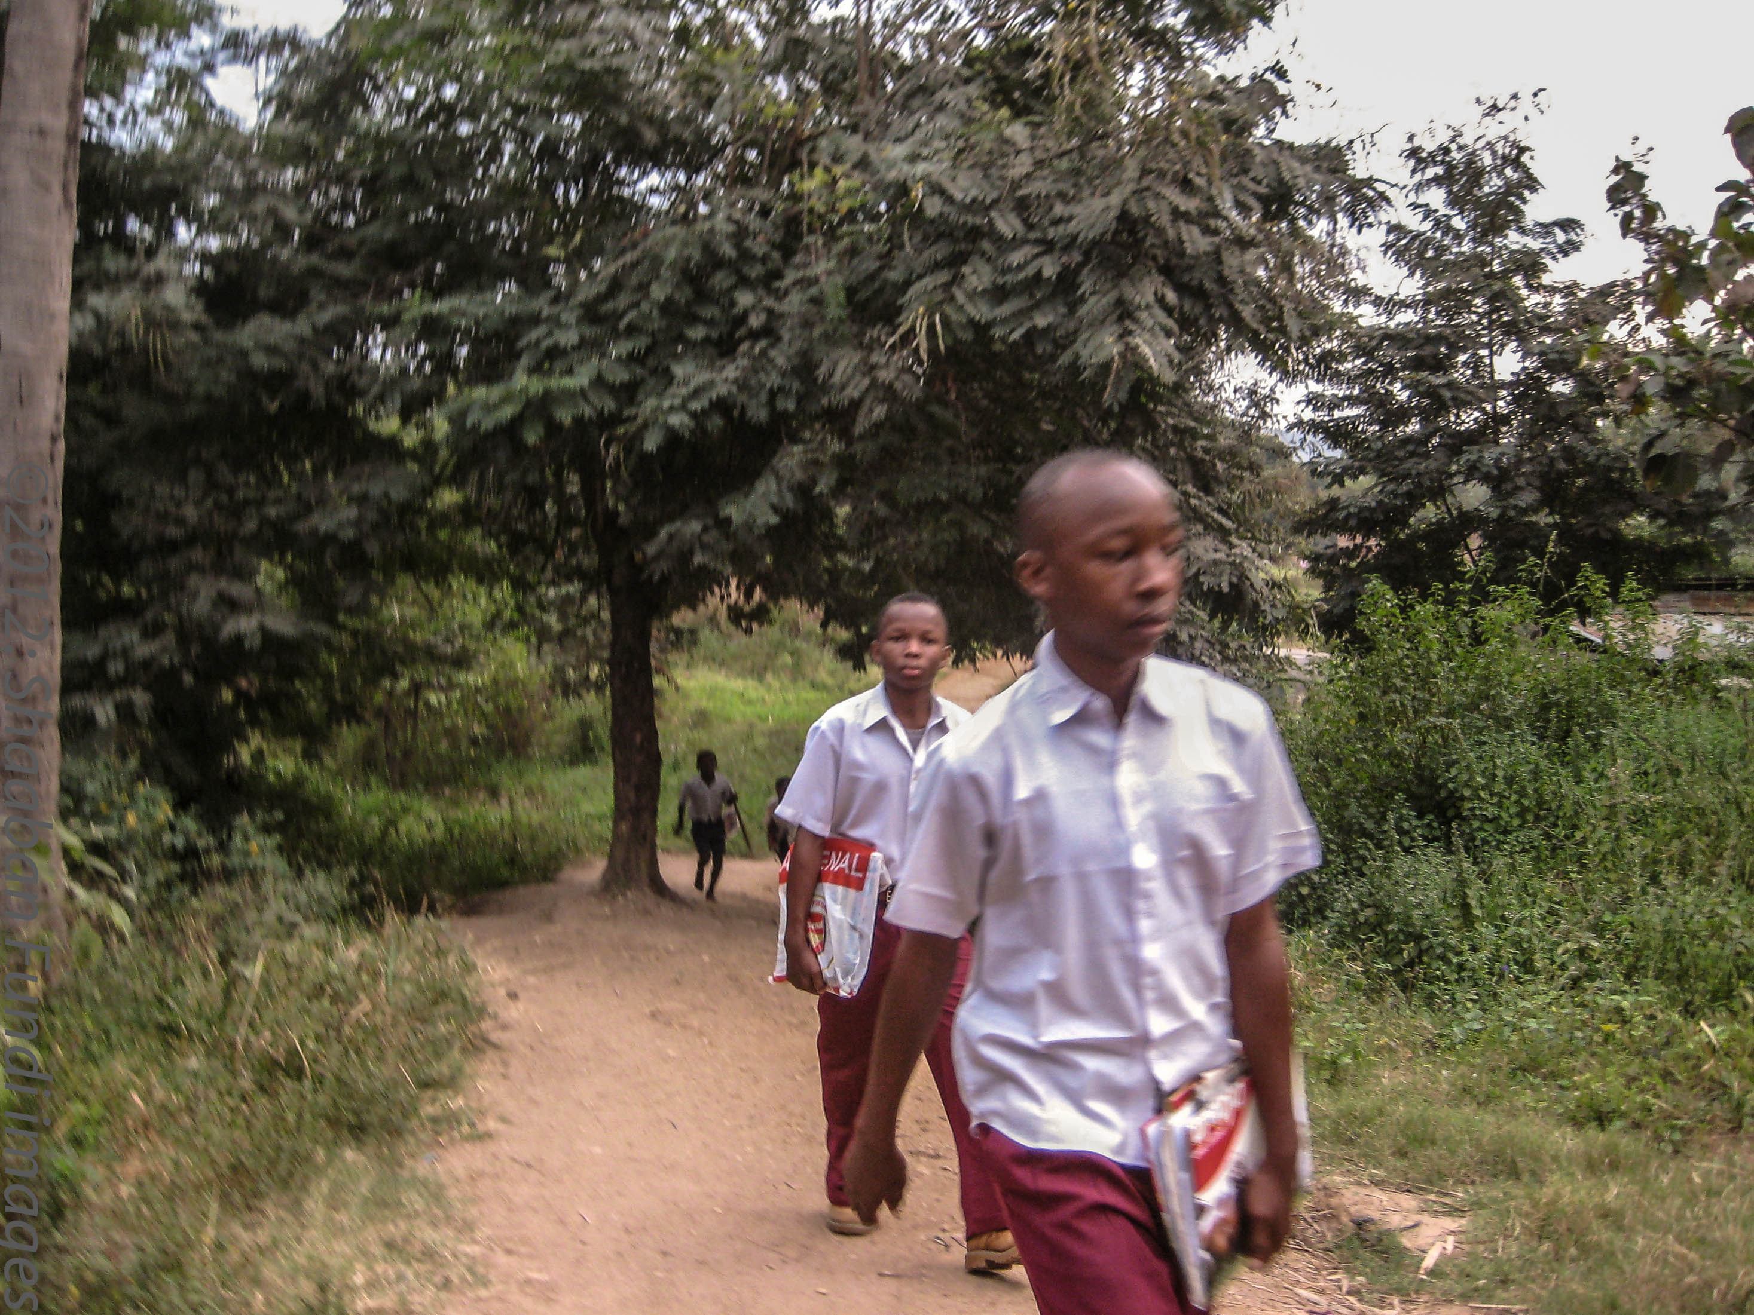

:EADLINE
Access to information:

To ensure that everyone in our community has access to daily newspapers, resource books and Internet and computer-related technologies, we operate a computer/library drop-in center.

The drop-in center operates seven days a week for 70 hours. It is equipped with a small library stocked with resource books, daily newspapers and internet.

Training the locals to use the Internet for their work and also to access government and non government sponsored programs on agriculture, jobs and health care.
Teachers Program:

Kibogoji Experiential Learning Center, Inc. operates a professional development program for teachers. This program will brings in teachers to the center to learn how to deliver engaging lessons to students using hands-on activities and project based learning strategies. The program will teach teachers how to use students grouping activities and/or strategies, computer assisted technologies in teaching and videos to enhance student learning.

Services we offer:
Collaborate with us or donate



