


TECHNICAL REPORT ON MIRACLE CURE PRESCRIBED BY REV. AMBILIKILE MWASUPILE IN SAMUNGE VILLAGE, LOLIONDO, ARUSHA

PREPARED BY

HAMISI M. MALEBO (Dip. Ed (Sc), B.Sc (Hons), M.Sc, PhD)¹ & ZAKARIA H. MBWAMBO (M.Pharm, PhD)²

INSTITUTIONS
¹DEPARTMENT OF TRADITIONAL MEDICINE RESEARCH, NATIONAL INSTITUTE FOR MEDICAL RESEARCH, P.O. BOX 9653, DAR ES SALAAM, TANZANIA.
²INSTITUTE OF TRADITIONAL MEDICINE, MUHIMBILI UNIVERSITY OF HEALTH AND ALLIED SCIENCES, P.O. BOX 65001, DAR ES SALAAM, TANZANIA.

MARCH, 2011
Acknowledgement
The Ministry of Health and Social Welfare (MoHSW) is gratefully acknowledged for financial support which enabled us to visit Arusha, Wasso and Samunge village in Loliondo ward. Arusha region authority: RC, RAS and RMO are thanked for their cooperation during the meetings to establish the administrative and governance of the situation in Samunge village. The RMO is once more acknowledged for organizing and accompanying the team during the whole duration of the survey. Ngorongoro district authority: DC, DED and OCD are thanked for their cooperation and great support and directives, and also for accompanying the research team to Samunge village for the field survey. Reverend Ambilikile Mwaisupile is acknowledged for his humility and humbleness in his attention in receiving and cooperating with the team and for his permission to access the medicinal plant and to collect samples for research. Aides of Rev. Mwasupile are acknowledged for their assistance in observing the herbal remedy preparation process and in the collection of samples for scientific investigation.
Table of contents
Acknowledgement …………………………………………………………………… | 2
Acronyms ………………………………………………………................................ | 4
1.0 Background to the “miracle cure” in Samunge village ………………………… | 5
2.0 Terms of references ……………………………………………………………… | 7
3.0 Methodology …………………………………………………………………….. | 8
4.0 Findings …………………………………………………………………………… | 9
5.0 General conclusions ……………………………………………………………… | 21
6.0 Recommendations and way forward …………………………………………… | 22
7.0 References ……………………………………………………………………….. | 23
Annex A: Informed consent form | 24
Acronyms
AIDS | Acquired Immune Deficiency Syndrome
DAC | District AIDS Coordinator
DC | District Commissioner
DED | District Executive Director
DHO | District Health Officer
HIV | Human Immunodeficiency Virus
HSV | Herpes Simplex Virus
KEMRI | Kenya Medical Research Institute
MoHSW | Ministry of Health and Social Sciences
MUHAS | Muhimbili University of Health and Allied Sciences
NAPRALERT | Natural Product Alert
NIMR | National Institute for Medical Research
RAS | Regional Administrative Secretary
RC | Regional Commissioner
RHS | Regional Health Secretary
SINV | Sindbis Virus
UDSM | University of Dar es Salaam

1.0 Background to the “miracle cure” in Samunge village, Loliondo, Arusha

Something big and quiet unusual has been happening since August, 2010 in Samunge village in Loliondo, Arusha. People have been flocking in the area from all over Tanzania for the believed cure for chronic diseases such as Diabetes, Asthma, Epilepsy, Cancer and HIV/AIDS. The miracle cure is being provided by retired Evangelical Lutheran Church Reverend Ambilikile Mwasupile (76). According to Rev. Mwasupile, God instructed him through dreams since 1991 about the medication and that, it will heal people with chronic illnesses namely: diabetes, asthma, epilepsy, cancer and HIV/AIDS. The dream kept recurring to him several times since then and on August 26, 2010 he decided to obey on the instructions and started the healing work.

He was instructed to only charge T.shs 500 for the dose which is one cup of the medication which should not be repeated once taken. He further explained about the distribution of the charged money that T.shs 300 is offered as sacrifice in the church and the remaining T.shs 200 is kept for paying helpers and other expenses related to the service. According to Rev. Mwasupile, the medication comes from the tree shown to us called “Mugariga” which was re-identified by the Maasai as “Engamuriaki” or “Olmuriaki” and Sonjo (Batemi) as “Engamuriaga”. Before the whole root of the medication is prepared and prescribed to patients, he prays to God and then it is boiled in clean water to a boiling point for about one hour, cooled, decanted and then prescribed.

Rev. Mwasupile further claimed that, in order for the medication to work, he has to be the only one who draws and dispense into cups to be administered to patients and that it starts working immediately.

There have been several reports from some people who used the remedy claiming to have been relieved and some of them cured of their chronic ailments. Such reports of existing hope for the cure of chronic illnesses has attracted people from all over Tanzania, other east African countries and beyond to visit Samunge village for the treatment. Photographs below provide a narration to the situation.

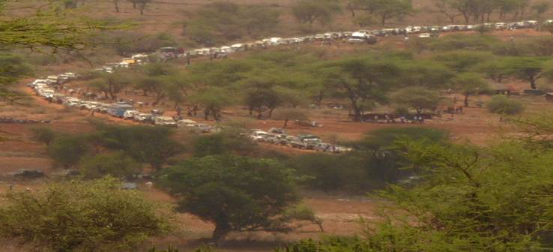
Photo 1: Big que of vehicles in an 18 km stretch from Rev. Mwasupile’s prescription point

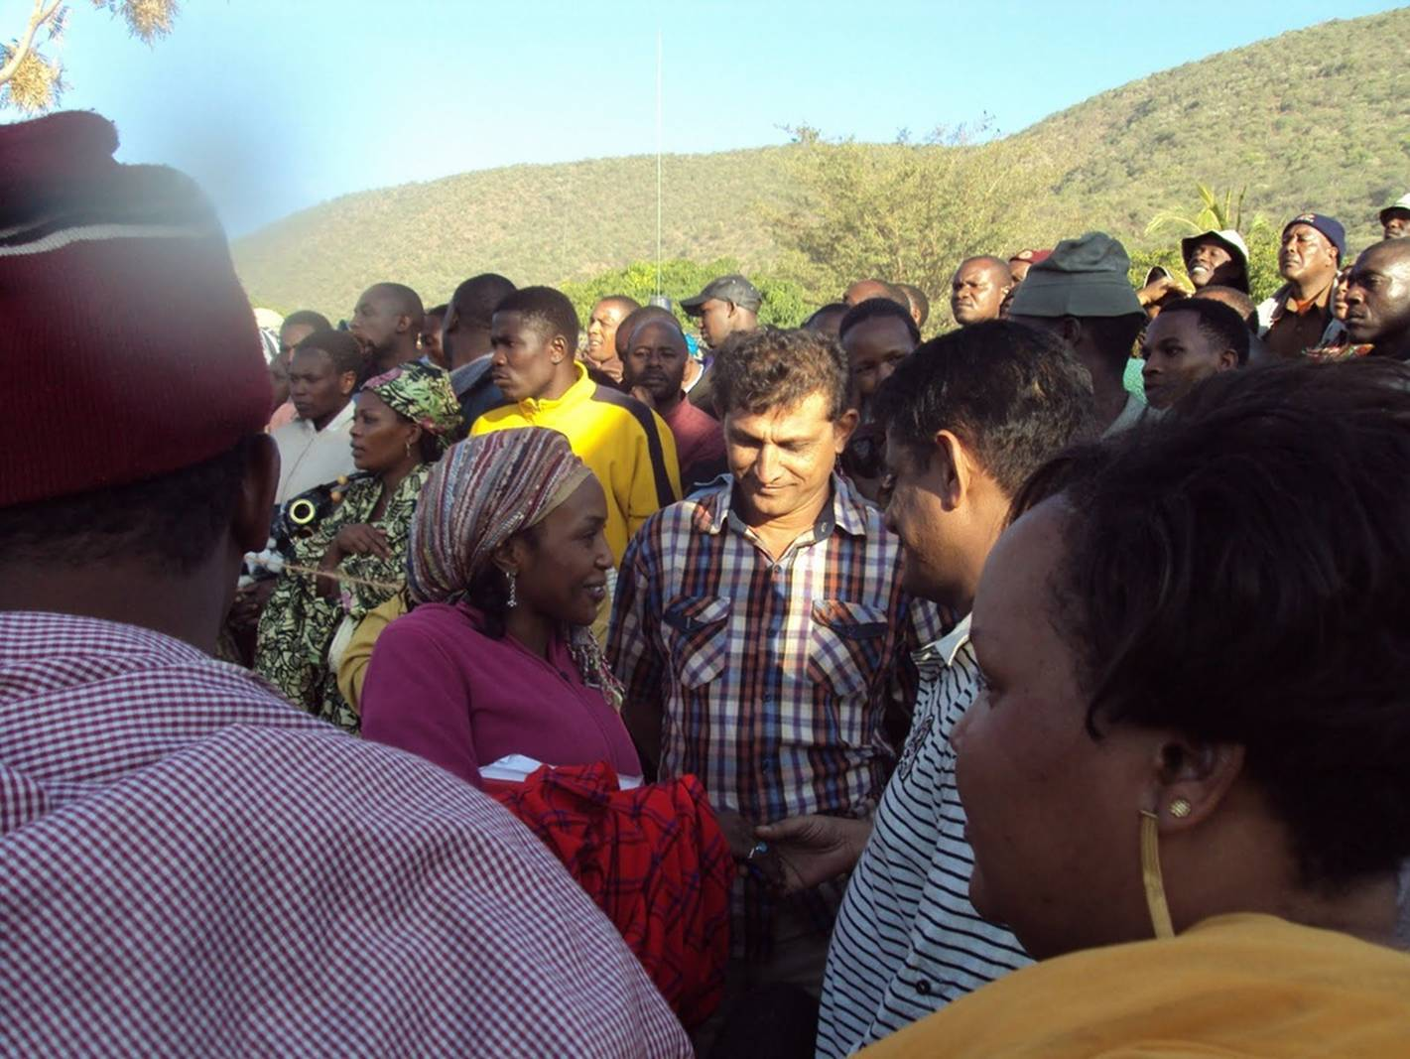
Photo 2: Section of the multitude waiting for their turn to receive the remedy

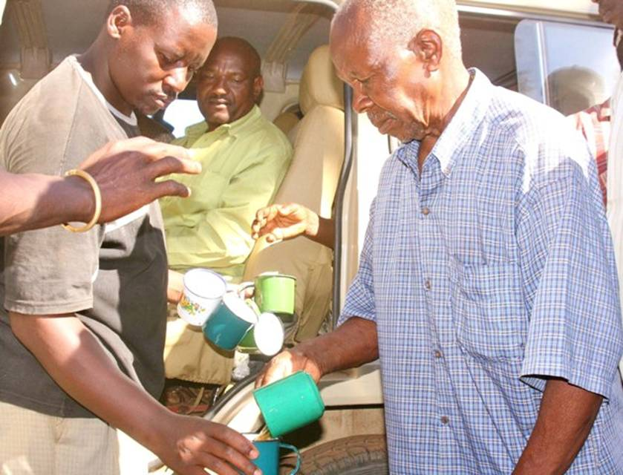
Photo 3: Rev. Mwaisupile prescribing the remedy to a client

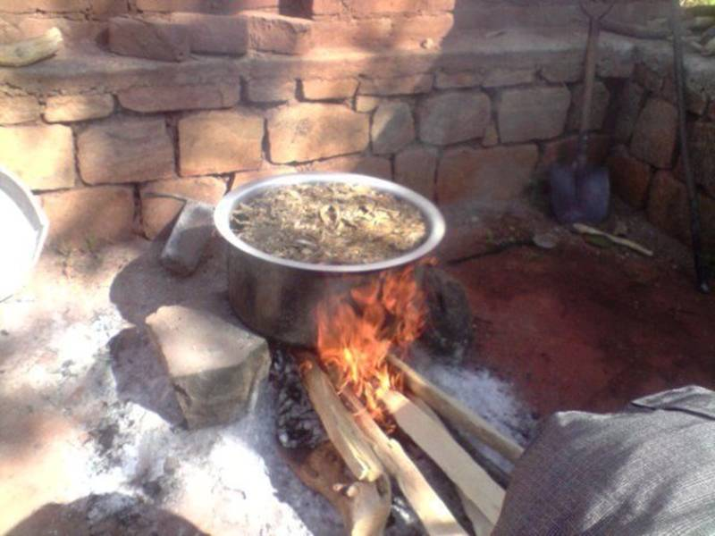 | 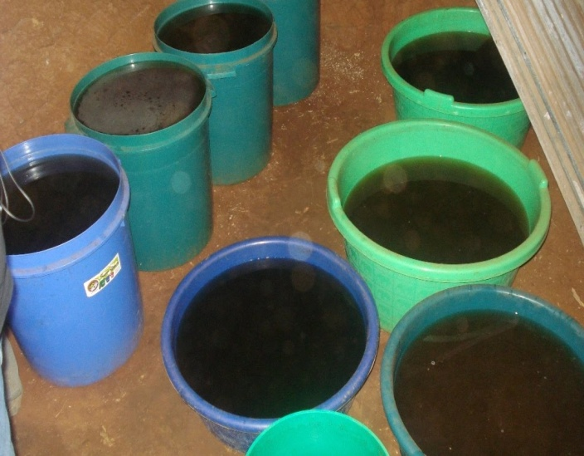
Photo 4: Herbal remedy being boiled | Photo 5: Cooled and decanted herbal remedy ready to be prescribed
2.0 TERMS OF REFERENCES
The Ministry of Health and Social Welfare (MoHSW) requested the NIMR and ITM to visit Rev. Mwasupile at the site and provide technical advice and recommendations on the following:
  - Ethnomedical claims and use of the remedy in the immediate community
  - Safety of the remedy as prepared and prescribed by Rev. Mwaisupile
  - Efficacy of the remedy as per claims by Rev. Mwaisupile
  - System for clinical follow up of patients taking the remedy
3.0 METHODOLOGY

3.1 Interviews with Arusha region authority
Interviews were conducted at Arusha regional level with the acting Regional Commissioner (RC), acting Regional Administrative Secretary (RAS), Regional Medical Officer (RMO) and Regional Health Secretary (RHS) to establish on the efforts already done and identify gaps. At Ngorongoro district level, interviews were conducted with District Commissioner (DC), District Executive Director (DED), District Health Officer (DHO) and District AIDS Coordinator (DAC).

3.2 Interview with Rev. Mwaisupile and some members of Samunge village
Interview was conducted with Rev. Mwaisupile on the remedy, specifically on the medicinal plant used, harvesting process, preparation, boiling process, cooling, decantation and dispensing procedure. Members of Samunge village were interviewed and asked for their opinions on the remedy and previous record of use of the used medicinal plant as to whether it is known to the community and also if there are medicinal and other uses of the plant.

3.3 Structured observation on herbal drug preparation and dispensation
Structured observation was done on the medicinal plant used; voucher specimen collected, a portion of whole root material used in making the remedy was also collected for further studies. The team spent time on observing closely on how the remedy was prepared to the last step when it is dispensed for use by the patients.

3.4 Botanical description
The voucher specimen of the medicinal plant was identified by the Plant Taxonomist, Mr. Frank Mbago, from the Department of Botany at the University of Dar es Salaam (UDSM) in Tanzania.

3.5 Literature review
Review of available scientific information on the identified medicinal plant was carried out using google internet search engine, Natural Product Alert (NAPRALERT), PUBMED and Science Direct databases.
4.0 FINDINGS

4.1 The miraculous plant
It was made evident from the interviews that, the medication comes from the tree called “Mugariga” which was re-identified in Samunge village by the Maasai as “Engamuriaki” or “Olmuriaki” and Sonjo (Batemi) as “Engamuriaga”.

4.2 Scientific description of the miraculous plant
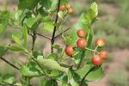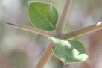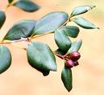
4.2.1 Botanic description
Plant Taxonomist identified the miraculous plant as Carissa spinarum (formerly Carissa edulis) which belongs to the family Apocynaceae. It is a spiny, branched, small tree, up to 5 m in height, with a milky sap. Young branchlets with or without hairs; spines simple, straight, 2-5 cm long, usually single. Leaves ovate to ovate-elliptic, opposite, occasionally almost circular, 2.5- x 1.8-3 cm, leathery, dark green above, paler green below, with or without short, soft hairs; lateral veins obscure; apex tapering, often with a bristle-like tip; base rounded to shallowly lobed; margin entire; petiole 1-4 mm long. Flowers white tinged with purple, red or pink, up to 1.8 cm long, about 2 cm in diameter, slender, tubular, with corolla lobes overlapping to the right, sweetly scented, in terminal heads about 4 cm in diameter. Fruits ovoid to almost spherical, up to 1.1 cm in diameter, red-black, ripening to purplish black, containing 2-4 flat seeds. C. edulis closely resembles C. bispinosa, the obvious feature separating them being that C. edulis has straight thorns and those of C. bispinosa are Y-shaped. The name Carissa is probably derived from the Sanskrit ‘corissa’, a name for one of the Indian species of the genus. The specific name, edulis, means edible.

4.2.2 Species distribution
The plant is native in the following countries: Australia, Botswana, Cambodia, Cameroon, Eritrea, Ethiopia, Ghana, Guinea, Japan, Kenya, Myanmar, Namibia, Nigeria, Papua, Saudi Arabia, Senegal, South Africa, Sudan, Tanzania, Thailand, Uganda, Vietnam and Yemen.
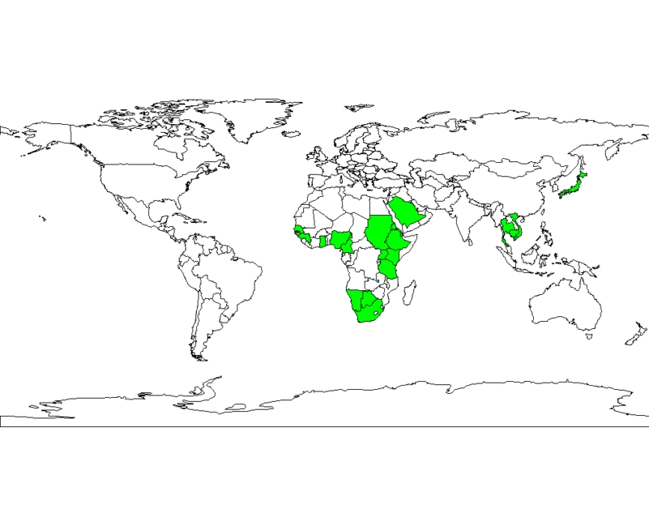
4.3 Traditional use of the plant
The plant is commonly known among Maasai people as “Engamryaki” also “Olmuriaki” and “Engamryaga” by the Sonjo. Engamryaki is added to milk and meat-based soups by the Maasai and Sonjo in Ngorongoro district in Tanzania (Johns et al., 1999). The use of local plant materials including Engamryaki as normal dietary additives is common among pastoralist tribes namely; Maasai, Sonjo, Gogo, Kurya and Barbaigs in Tanzania. Fruits are sweet and pleasant to eat; in Ghana, they are normally added to the food of sick people as an appetizer. Vinegar has been made from them by fermentation; in Sudan and Kenya, they are made into a jam. The roots are put into water gourds by the Maasai to impart an agreeable taste and are added to soups and stews for the same reason. Goats and camels in the dry parts of Sudan browse on C. edulis.

The plant parts are used in ethnomedicine for wide variety of illnesses, such as epilepsy (Ya’u et al., 2008), headache, chest complaints, gonorrhea, syphilis, rheumatism, rabies and as well as a diuretic (Nedi et al., 2004). Other folkloric uses of Carissa edulis include fever, sickle cell anaemia and hernia (Ibrahim, 1997).
C.edulis is the best known as member of the genus Carissa as it has been used as a traditional medicinal plant over thousands of years in the ayurvedic system of medicine as it is practiced on the Indian sub continent (Pakrashi et al., 1968). The root is credited with stomachic, antidiarrhoel and antianthelmintic properties. The ripe fruits are utilized in curries, tarts, puddings and chutney. When only slightly under ripe, they are made into jelly (Pakrashi et al., 1968).

4.4 Scientific data on Engamryaki
4.4.1 Safety data
Previous toxicological investigation revealed Engamryaki to be generally safe. The median lethal dose (LD₅₀) of Carissa edulis in the tested experimental mice was:
- 282.8 mg/kg following intraperitoneal administration (Ya’u et al., 2008).
- Over 5000 mg/kg following oral administration (Ya’u et al., 2008).

Conclusion: These results show the plant is safe especially when taken orally. The dose provided by Pastor Ambilikile Mwasupile, which is one cup (about 200 mls) prepared through boiling an estimated 3.0 kg of whole root material in 60 litres of water falls within safety window and no any overdose or acute poisoning event is expected.

4.4.2 Antiepileptic activity
Ya’u et al., 2008 demonstrated that Carissa edulis at 5 and 20 mg/kg, possessed significant anticonvulsant activity in mouse model investigated.

Conclusion: These results suggest that Carissa edulis has anticonvulsant activity which supports the ethnomedicinal claim of the use of the plant in the management of epilepsy as claimed by Pastor Ambilikile Mwasupile.

4.4.3 Antidiabetic activity
EI-Fikyet al., 1996, investigated the effect of oral administration of 2 g/kg body weight of the ethanolic extract of Carissa edulis (leaves) on blood glucose levels both in normal and streptozotocin (STZ) diabetic rats. Treatment with C. edulis extract significantly reduced the blood glucose level in STZ diabetic rats during the first three hours of treatment with potency similar to that of the biguanide, metformin. On the other hand, in normal rats, it produced insignificant changes in blood glucose levels compared to glibenclamide treatment. It was postulated that, C. edulis contain some hypoglycaemic principles which act probably by initiating the release of insulin from the pancreatic β-cells of normal animals (sulfonylurea-like effect).
Conclusion: These results suggest that Carissa edulis has antidiabetic activity which supports the ethnomedicinal claim of the use of the plant in the management of diabetes as claimed by Pastor Ambilikile Mwasupile.

4.4.4 Cardiotonic activity
The cardiotonic activity and prolonged blood pressure lowering effect of Carissa edulis was previously reported (Vohra & De, 1963). The cardiac activity of water-soluble fraction has been attributed to the presence of the odoroside glucosides.

Conclusion: These results suggest that Carissa edulis has blood pressure lowering activity which supports the ethnomedicinal claim of the use of the plant in the management of high blood pressure.

4.4.5 Hepatoprotective and antioxidant activity
Carissa edulis extract has demonstrated strong hepatoprotective and antioxidant activity in experimental Wistar albino rats which was confirmed through measurements of serum glutamate oxaloacetate transaminase (SGOT), serum glutamate pyruvate transaminase (SGPT), serum alkaline phosphatase (SALP), uric acid, total protein content and total bilirubin content. Antioxidant action was determined by estimating lipid peroxidation, reduced glutathione (GSH), super oxide dismutase (SOD) and catalase (CAT) activity in liver (Chatterjee & Roy, 1965).

Conclusion: These results suggest that Carissa edulis has hepatoprotective and antioxidant activity which are beneficial in the prevention of liver disorders and cancer and hence supports the ethnomedicinal claim of the use of the plant against chronic illnesses.

4.4.6 Anti-viral activity against herpes simplex virus
Carissa extracts has been reported to possess potent antiviral activity against Sindbis virus (SINV) at 3 µg/ml, polio virus (POLIO) at 6 µg/ml, HIV-1 and herpes simplex virus (HSV) at 12 µg/ml (Tylor, 1996). Tolo et al., (2006) at Kenya Medical Research Institute (KEMRI) in Kenya, demonstrated that, an aqueous total extract preparation from the roots of Carissa edulis exhibited remarkable anti-herpes simplex virus (HSV) activity in vitro and in vivo. The extract signiﬁcantly inhibited formation of plaques in Vero E6 cells infected with 100 PFU of wild type strains of HSV (7401⁻H HSV-1 & Ito-1262 HSV-2) and resistant strains of HSV (TK-7401⁻H HSV-1 &AP^{r} 7401H HSV-1) by 100% at 50 μg/ml in vitro with very low cell cytotoxicity (CC₅₀ = 480 μg/ml).

Tolo et al., (2006) also demonstrated the in vivo efficacy in a murine model using Balb/C mice cutaneously infected with wild type or resistant strains of HSV, the extract at an oral dose of 250 mg/kg signiﬁcantly delayed the onset of HSV infections by over 50%. It also increased the mean survival time of treated infected mice by between 28 and 35% relative to the infected untreated mice (p < 0.05 versus control by Students t-test). The mortality rate for mice treated with extract was also signiﬁcantly reduced by between 70 and 90% as compared with the infected untreated mice that exhibited 100% mortality. No acute toxicity was observed in mice at the oral therapeutic dose of 250 mg/kg.

Conclusion: This result reveals that Carissa edulis has potent anti-viral activity against herpes simplex viruses. Taking into consideration that, herpes simplex virus (HSV) infection is a major opportunistic infection in immunosuppressed persons, these findings supports the ethnomedicinal claim of the use of the plant in the management of HIV/AIDS as claimed by Pastor Ambilikile Mwasupile.
4.5. Chemical constituents
The chemical constituents of Carissa edulis include steroids, terpenes, benzenoids, phenylpropanoid, lignans, coumarins tannins, ﬂavonoids and cardiac glycosides (Ibrahim, 1997; Ibrahim et al., 2005; Achenbach et al., 1983; Bentley et al., 1984). Previous chemical analysis by Ibrahim et al., 2005, on Carissa edulis revealed the presence of compounds as shown in table 1 below.

Table 1: General phytochemical constituents of Carissa edulis
Chemical constituent | Result
- Tannins | Present
- Flavonoids | Present
- Anthraquinones | Absent
- Cardiac glycosides | Present
- Terpenes | Present
- Alkaloids | Absent

4.5.1 Classes of identified compounds in Carissa edulis

4.5.1.1 Sesquiterpenes
Sesquiterpenes are known to possess antimicrobial, antimalarial, anticancer and anti-inflammatory actions (Hettiarachchi, 2006). Sesquiterpenes known to occur in Carissa edulis are shown in table 2 below.

Table 2: Sesquiterpenes occurring in Carissa edulis
Sesquiterpenes
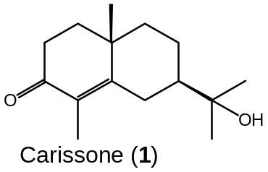 | 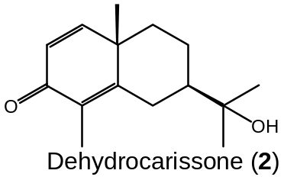
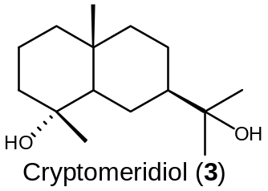 | 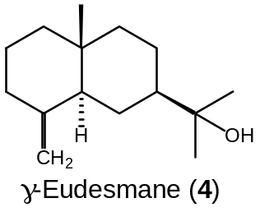

4.5.1.2 Triterpenes
Triterpenes are recognized to exhibit hepato-protective, anti-inflammatory and anti-hyperlipidemic properties (Gupta et al., 1980; Hettiarachchi, 2006; Malebo, 2009). Triterpenes modulates anti-oxidant enzymes in vitro, improves urinary symptoms and is a major ingredient of herbal therapy for benign prostatic hypertrophy (BPH). They do also decrease post-void residual urinary volume and increases urinary flow rate in BPH patients (Malebo, 2009). Thus, β-Sitosterol is among of several phytosterols with chemical structures similar to cholesterol, that are widely distributed in the plant kingdom. They reduce levels of cholesterol in blood, and sometimes are used for the treatment of hypercholesterolemia. Ursolic acid exhibits potent suppressive effect on HIV replication with EC₅₀ of 2.0 µg/ml.

Table 3: Triterpenes known to occur in Carissa edulis
Triterpenes
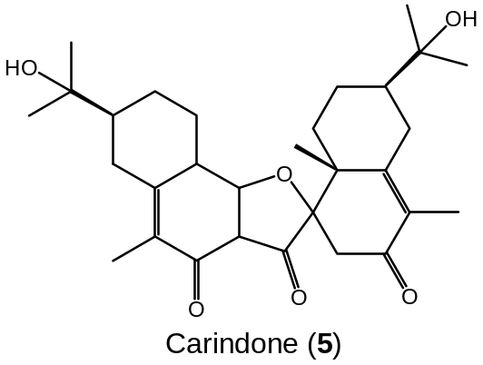 | 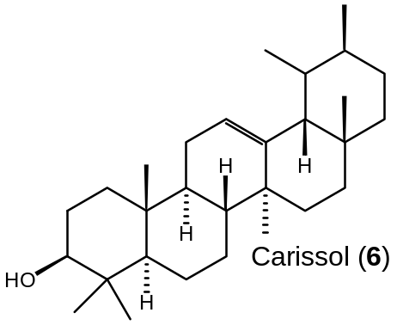
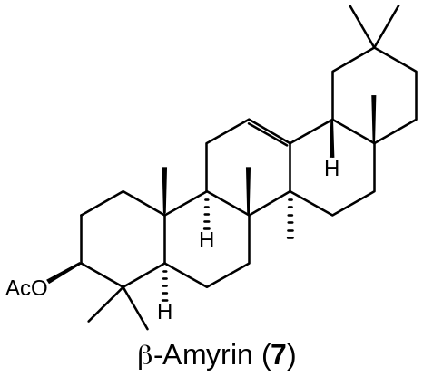 | 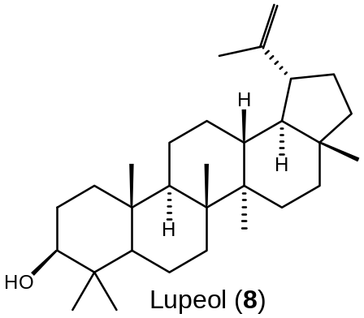
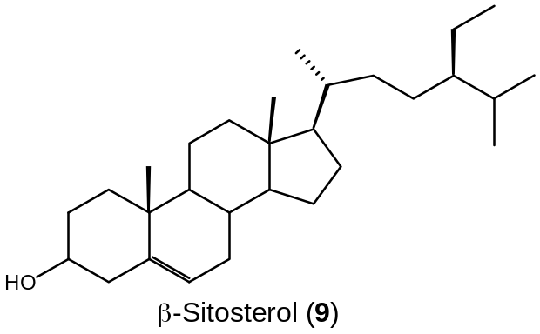 | 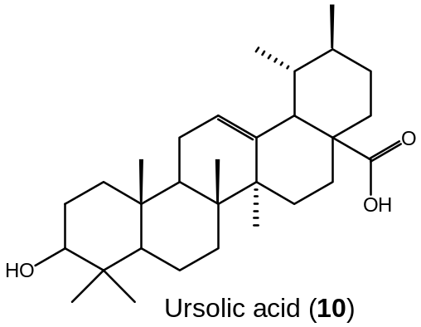

4.5.1.3 Phenylpropanoids and phenylethanoids
Phenylpropanoids (PPs) and phenylethanoids belong to the largest group of secondary metabolites produced by plants, mainly, in response to biotic or abiotic stresses such as infections, wounding, UV irradiation, exposure to ozone, pollutants, and other hostile environmental conditions. These numerous phenolic compounds are major biologically active components of human diet, spices, aromas, wines, beer, essential oils, propolis, and traditional medicine. Last few years, much interest has been attracted to natural and synthetic phenylpropanoids for medicinal use as antioxidant, UV screens, anticancer, anti-virus, anti-inflammatory, wound healing, and antibacterial agents.

Table 4: Phenylpropanoids and phenylethanoids known to occur in Carissa edulis
Phenylpropanoids and phenylethanoids
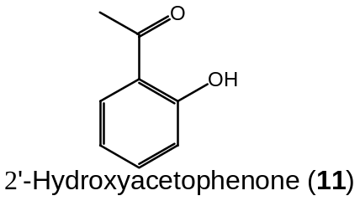 | 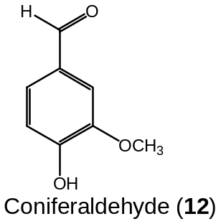
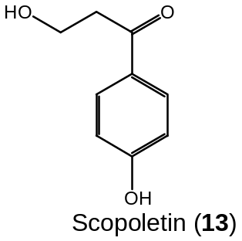 | 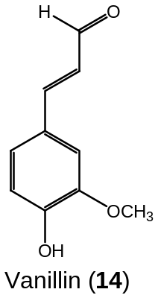
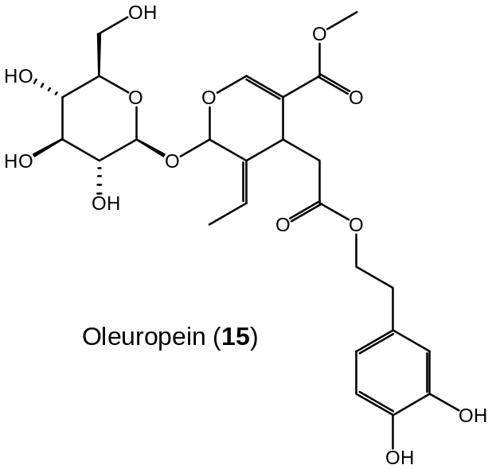

4.5.1.4 Lignans
In the plant world lignans are natural products which occupy quite a large area. They have been identified in some 70 families, many of which have been used in traditional medicine. Lignans have gained increasing attention due to their biological effects; antimitotic, antiviral, cathartic, allergenic and antitumour activity. The most important of these is their antitumour activity and several of them are in clinical use for treatment of cancer. Some lignans have been isolated from Carissa edulis as shown in the table below.

Table 5: Lignans known to occur in Carissa edulis
Lignans
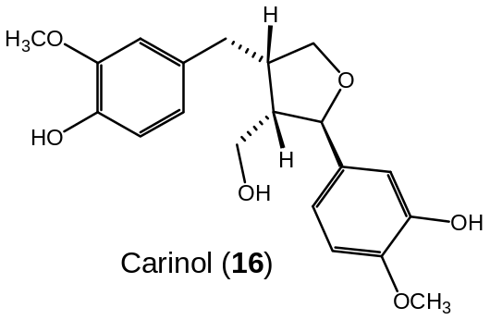 | 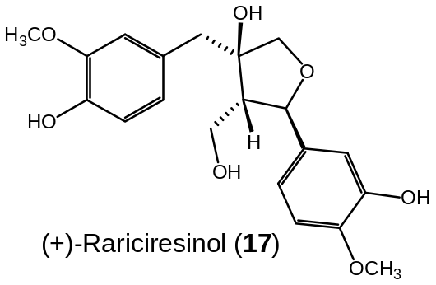
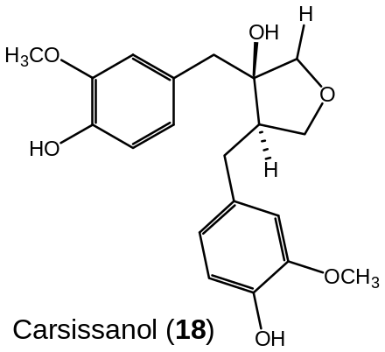 | 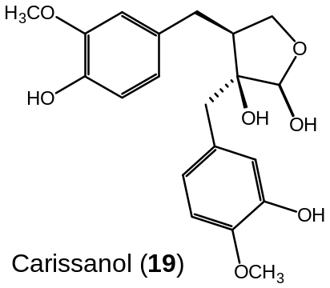
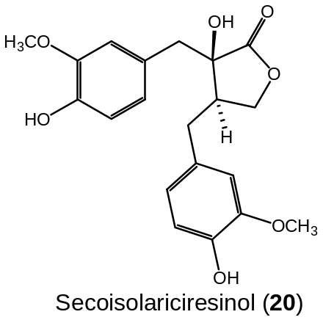 | 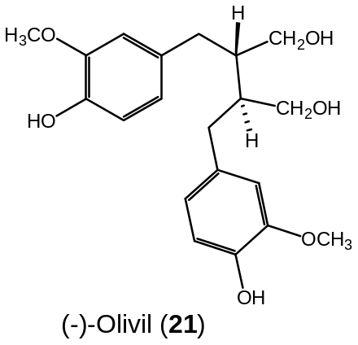
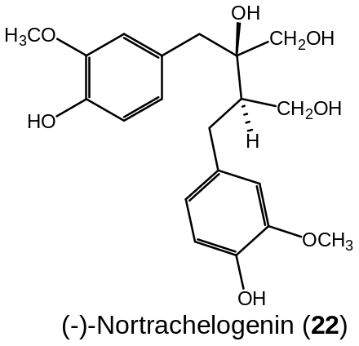

4.5.1.5 Coumarins
Coumarins have recently drawn much attention due to its broad pharmacological activities. Many coumarins and their derivatives exert anti-coagulant, anti-tumor, anti-viral, anti-inflammatory and antioxidant effects, as well as anti-microbial and enzyme inhibition properties. One coumarins has been isolated from Carissa edulis as shown in the table below.

Table 6: Coumarins known to occur in Carissa edulis
Coumarins
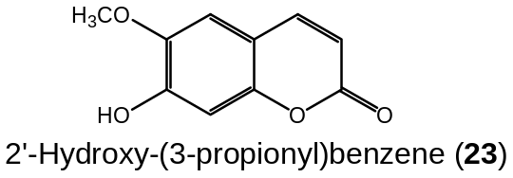

4.5.1.6 Cardiac glycosides
Cardiac glycosides occur naturally in certain plants species. Cardiac glycosides have effects on the heart, stomach, intestines, and nervous system. These are the active ingredient in many different heart medicines in clinical use and they are the major class of medications used to treat heart failure.

Table 7: Cardiac glycosides known to occur in Carissa edulis
Cardiac glycosides
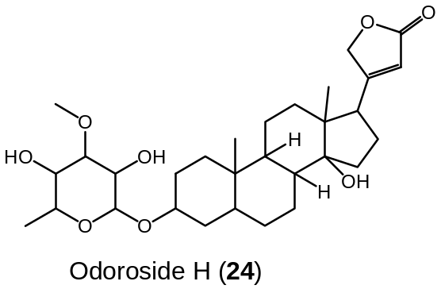 | 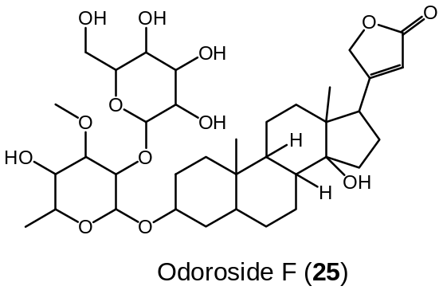

5.0 General conclusions
- The plant is safe and the dosage prescribed by Rev. Mwasupile is below the toxic level
- The available scientific data supports ethnomedical claims on the following pharmacological actions as:
- Anti-epileptic
- Anti-diabetic
- Cardiotonic
- Hepatoprotective
- Antioxidant
- Antiviral activity
- Isolated compounds have relevant activity which are beneficial to patients as:
- Sesquiterpenes: antimicrobial, antimalarial, anticancer and anti-inflammatory activities.
- Triterpenes: hepatoprotective, anti-inflamatory, anti-HIV and anti-hyperlipidemic activities.
- Phenylpropanoids and phenylethanoids: UV screens, anticancer, antiviral, anti-inflammatory, wound healing and antibacterial activities.
- Lignans: antimitotic, antiviral, cathartic, allergenic and antitumor activities.
- Coumarins: anti-coagulant, antitumor, antiviral, anti-inflammatory, antioxidant, antimicrobial and enzyme inhibitory activities
- Cardiac glycosides: treat heart, stomach, intestines and nervous system. Major treatment for heart failure.
6.0 Recommendations and way forward
Ever since the remedy is being widely used by an exceedingly large number of patients, we recommend the following:
- Focused pre-clinical studies need to be conducted to establish pre-clinical efficacy and safety of the remedy
- Standardization and formulation of dosages for human use
- The MoHSW should conduct clinical trial on the prescribed remedy to establish in vivo efficacy and safety in humans and answer questions on optimum dosage, dosing schedule and duration of treatment per ailment.
- The MoHSW should conduct clinical follow up on all patients recorded to have used the remedy for their prognosis using details filled in the NIMR consent form (Annex A).

7.0 References
Achenbach, H., Waibel, R., Addae-Mensah, I., 1983. Lignans and other constituents from Carissa edulis. Phytochemistry, 22(3), 749-753
Chatterjee, M.L. & Roy, A.R., 1965. Pharmacological action of Carissa carandus root. Bulletin of the Calcutta School of Tropical Medicine, 13(1), 14-6.
EI-Fiky, F.K., Abou-Karam, M.A. & Afify, E.A., 1996. Effect of Luffa aegyptiaca (seeds) and Carissa edulis (leaves) extracts on blood glucose level of normal and streptozotocin diabetic rats. Journal of Ethnopharmacology 50, 43-47.
Gupta, M.B., Nath, R., Srivastava, N., Shanker, K., Kishor, K., Bhargava, K.P., 1980. Anti-inflammatory and antipyretic activities of beta-sitosterol. Planta Medica 39, 157-163.
Hettiarachchi, D.S., 2006. Isolation, identification and characterization of antibacterial compounds from Carissa lanceolata R.Br. root. M.Pharm. Thesis, Curtin University of Technology.
Ibrahim, H., 1997. Pharmacognostic and Biological (Analgesic Activity) Studies of Carissa edulis Vahl. Ph.D. Thesis. Ahmadu Bello University, Zaria, Nigeria, pp. 232.
Ibrahim, H., Bolaji, R.O., Abdurahman E.M., Shok, M., Ilyas, N. and Habib A.G., 2005. Preliminary phytochemical and antimicrobial studies of the leaves of Carissa edulis VAHL. ChemClass Journal 2, 15-18.
Johns, T., Mahunnah, R.L.A., Sanaya, P., Chapman, L. & Ticktin, T., 1999. Saponins and phenolic content in plant dietary additives of a traditional subsistence community, the Batemi of Ngorongoro District, Tanzania. Journal of Ethnopharmacology 66, 1–10.
Nedi, T., Mekonnen, N., Urqa, K., (2004). Diuretic effect of the crude extract of Carissa edulis in rats. Journal of Ethnopharmacology 95, 57–61.
Pakrashi, S.C., Datta, S. & Ghosh-Dastidar, PP., 1968. Indian medicinal plants- XVII.3 Phytochemical examination of Carissa SPP. Phytochemistry 7(3), 495-6.
Tylor, S.R.S.L., 1996. Medicinal plants of Nepal: Ethnomedicine, Pharmacology and phytochemistry, PhD Thesis, University of british Columbia.
Tolo, F.M. et al. (2006) Anti-viral activity of the extracts of a Kenyan medicinal plant Carissa edulis against herpes simplex virus. Journal of Ethnopharmacology 104, 92–99.
Vohra, M.M.& De, N.N., 1963. Comparative cardiotonic activity of Carissa carandas and Carissa spinarum. Indian J Med Res. 51, 937-40.
Ya’u, J., Yaro, A.H., Abubakar, M.S., Anuka, J.A. and Hussaini, I.M., (2008). Anticonvulsant activity of Carissa edulis (Vahl) (Apocynaceae) root bark extract. Journal of Ethnopharmacology 120, 255–258.

ANNEX A: INFORMED CONSENT FORM

TITLE OF RESEARCH: CLINICAL FOLLOW UP FOR SAFETY AND EFFICACY OF “MRIGARIGA” IN THE TREATMENT OF CHRONIC ILLNESSES AS PRESCRIBED TO PATIENTS BY REV. AMBILIKILE MWASUPILE OF LOLIONDO DISTRICT

We are asking you to take part in this research study. The aim of this investigation is to medically follow up patients receiving the remedy to monitor progress of patients under the treatment. If you consent, you will be requested to attend the nearest district, regional or referral hospitals in your area for regular medical examination. Costs for your medical examination will be met by the Ministry of Health and Social Welfare (MoHSW). Information obtained about your previous condition and clinical progress will be kept private to the extent allowed by law. Your name and any other of your identity will not be disclosed at any circumstance as provided by the law. In order to make this follow up we need to be in touch with you, kindly accord us your name and full address only for our internal use as stated above.

The results of the study will be used by the MoHSW to advise the government on the treatment of chronic illnesses using herbal remedies. This information will also be used to inform the international community. These results will only include codified information and your identity will not be given out. Your taking part in this study is your choice. There will be no penalty if you decide not to be in the study. If you decide not to be in the study, you will not lose any benefits you are otherwise owed. You are free to withdraw from this research study at any time. Your choice to leave the study will not affect your relationship with MoHSW and NIMR. There will be no cost to you from taking part in this study.

If you have any questions, concerns, or complaints about the study, please contact Dr. Mwelecele N. Malecela, Director General of NIMR. She will be glad to answer any of your questions. Dr. Malecela’s phone number is 0784333444. Dr. Malecela would be glad to address your questions about your rights as a research participant, or concerns or complaints about the research, you can also write to the Director General, National Institute for Medical Research, P.O. Box 9653, Dar es Salaam, and phone number 0222121400.

You are making a decision whether or not to participate in this study. Your signature indicates that you have read (or been read) the information provided above and decided to participate.
You will receive a copy of this signed informed consent document.

Signature of Patient Receiving the treatment:………………………………………Date
Or Legally Authorized Representative
Full Name: ………………………………………………………………………………………………….
Address: ………………………………………………………………………………………………………………
Mobile phone: ………………………………………………………………………………………………
Signature of Investigator ………………………………………………… Date …………………………..

Name of Witness: …………………………………Signature: …………………… Date: …………………

Address: ……………………………………………………………………. Phone: ………………………

